Friday 15th May 2020
Hello! I hope you are all keeping safe and having fun at home. This week’s sound is ‘a’. We write this sound by following the rhyme – ‘round the apple, down the leaf’. Please practice writing this with your child – this can be done in lots of different ways including;
- Writing in sand, glitter, sugar, sprinkles
- Using paintbrushes and water outdoors
- Using chalk outdoors
- Using watercolour paint or poster paint
- Writing with glue and sprinkling glitter, sequins or small collage materials on top
- Writing on foil
- Using crayons, pastels, felt tips, pencils – the more different experiences, the better!
You could make some simple mark making tools using pegs and a variety of different materials. These are lots of fun to use with paint and practice making lots of different marks and writing your name. Discuss the different textures and effects that they give. I have included a picture below for inspiration but you can use anything that is lying around the house. You could also look for natural resource to add to your pegs during your daily walk
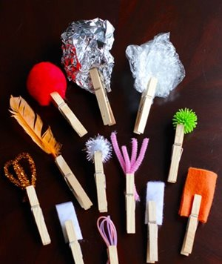
Some activities that you can do relating to this sound are;
- Eat apples
- Make paper airplanes
- Dress as astronauts and ambulance drivers.
- Go on an animal adventure; be apes, alligator, armadillos.
- Talk about being angry
- Make arrows from long straws
I have uploaded a Powerpoint called ‘Dr Dog’ which helps to explain the coronavirus pandemic to young children in an age-appropriate way. The use of story books can be a valuable vehicle for this. Use this book to explore Covid-19 with your child, through the character, Dr. Dog. This story has been written in partnership with the London School of Hygiene and Tropical Medicine and illustrated by Lydia Monks, a famous children’s illustrator.
After reading this together, create an opportunity for your child to share their feelings and thoughts about coronavirus. Do they have any questions? You could create a poster or book together with your child’s illustrations and you can scribe their thoughts. This would be interesting to look back on in the future, when your child is older
Practice writing your name and different sounds every day and sing some counting songs on YouTube.
In Nursery, as well as learning the 26 sounds of the alphabet (we call this Phase 2 Phonics), we recap on Phase 1 throughout the year.
In Phase 1 phonics, children are taught about:
- Environmental sounds.
- Instrumental sounds.
- Body percussion (e.g. clapping and stamping)
- Rhythm and rhyme.
- Alliteration.
- Voice sounds.
- Oral blending and segmenting (e.g. hearing that d-o-g makes 'dog')

Each week, I will upload a different aspect of Phase 1 with suggested activities, to ensure children are still practising these skills. These week, I have uploaded some ideas for teaching ‘environmental sounds’. There are also lots of ideas for this on Pinterest and Google. There are also games on YouTube if you type in ‘environmental sounds phase 1’, there are several listening games that ask you child to guess what sound they can hear. Try some of these activities alongside listening to Jolly Phonics.
Take care and stay safe,
I miss you all!
Miss Fishwick

